Slovak university of technology in Bratislava
Faculty of Informatics and Information technologies

Systems Thinking in IT
User Manual

Author: Milan Bohňa, Ján Lenický, Samuel Sagan
Akademic year: 2021/2022

Melody settings
Each tone is played by a pin which is embedded to the hole in cylinder. Pins are represented by screws (different material would also be suitable).
- Gather sheet notes for the desired song (Maximum number of distinct tones - 12)
- Install needed tone plates onto the comb (Each plate is tuned to play specific tone in range of two octaves C4 to B5). It’s crucial to align the ending edge of the plates on the same level in order to prevent a drum damage. The distance between the comb and cylinder is approximately 1,5 cm.
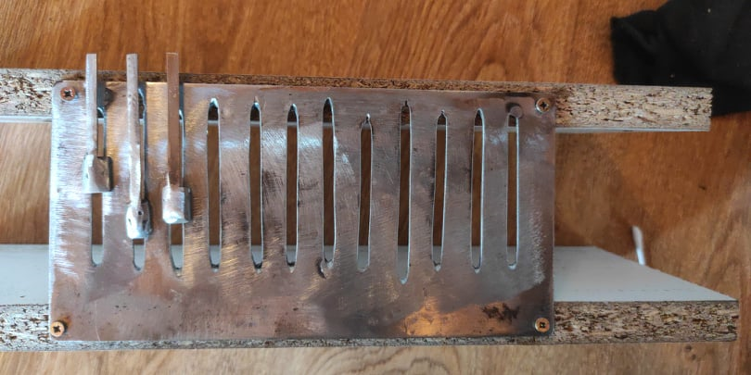
- Install pins into corresponded holes in cylinder as shown in figure below
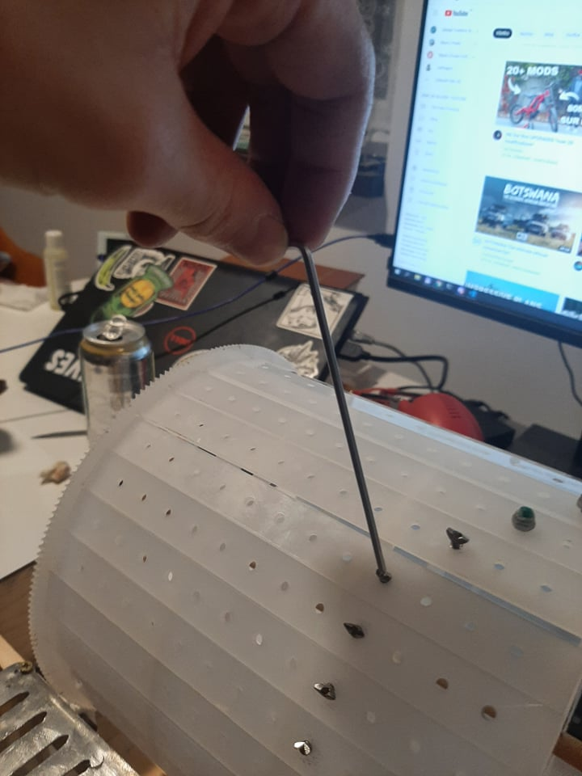
- Check the alignments and if everytings fits, proceed to tempo customization step.

Tempo customization
Tempo is regulated by Arduino extended with motor driver shield. Our solution also offers the manual control of a cylinder by the lever.
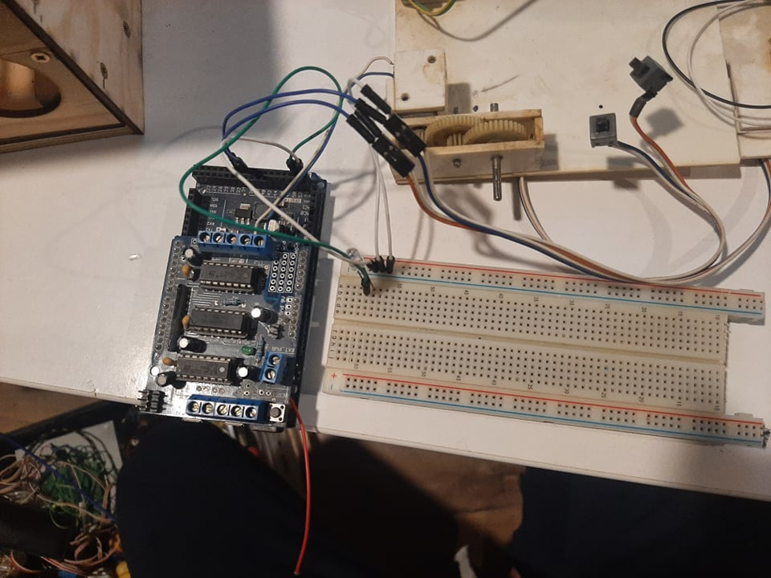
- Check the original song tempo from sheet notes
- Power up the Arduino and by using up and down switches set the tempo shown on display to requested value
- Hit play button which starts the engine that runs cylinder
- Enjoy your music

