Slovak university of technology in Bratislava
Faculty of Informatics and Information technologies

Systems Thinking in IT
Technical documentation

Author: Milan Bohňa, Ján Lenický, Samuel Sagan
Akademic year: 2021/2022

Components
MusicBox components of our solution are shown in the following diagram:
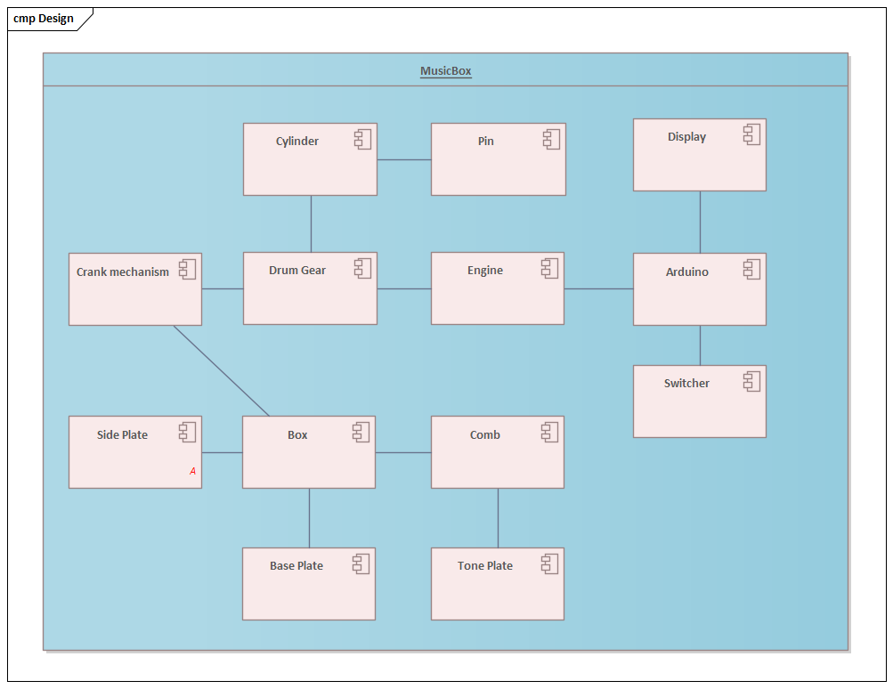

Box
A case is constructed by five wooden plywood plates (base plate, two side plates, middle plate and front plate) joined together with construction wood screws.
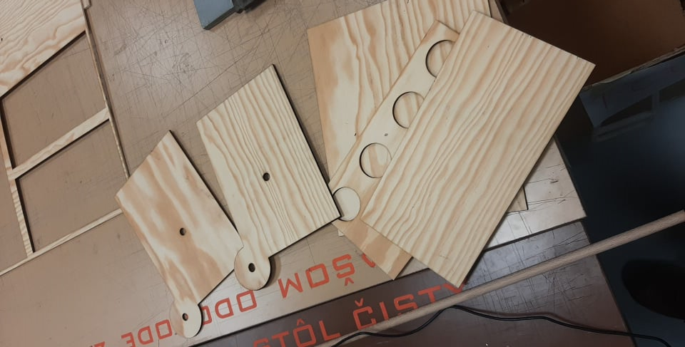

Comb
Comb is composed of two main parts:
- 5mm thick metal base plate with carved slots
- Metal pins that are placed into the slot (tuned to play specific tone)
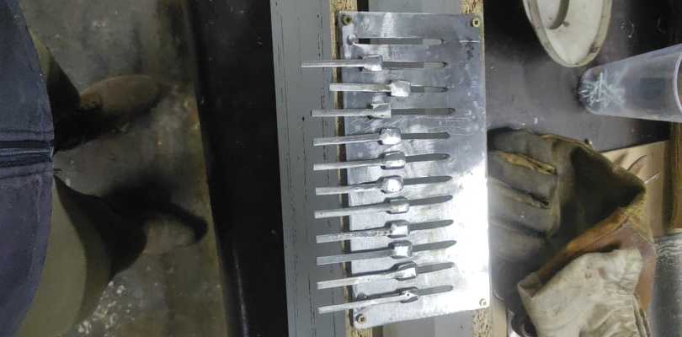

Cylinder
Material used for cylinder construstion is acrylic plexiglass. Cylinder body is filled by joining 36 parts cut out by laser with glue. Each part containts 12 evenly distributed holes which are used for holding the pins.
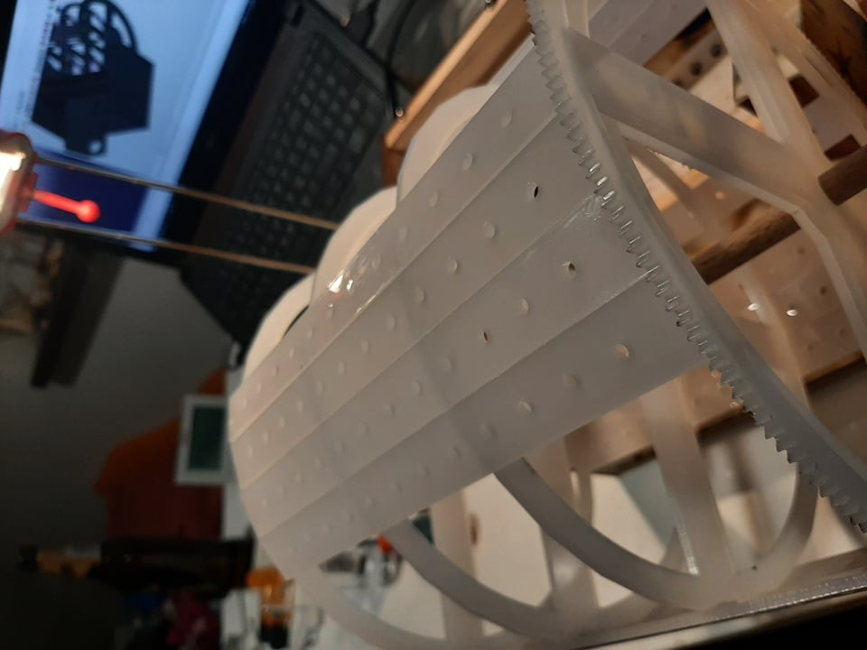

Cranking mechanism
DC Engine and Gear wheel are representing the cranking mechanism of the musicbox. DC Engine is rotating based on electric signals delivered from Arduino shield and gear will connect the engine with cylinder.

Arduino
We are using Arduino Mega 2560 mini kit that is supposed to regulate the engine’s rotations per minute using Motor driver shield L293D. The current tempo is shown on mini display and user can modify the value using two switch buttons (Up and Down). After confirming the value by pressing play button, Arduino shield calculates rotation speed and runs the engine with required regulated speed.
